**Main Deliverable**

Individual ?? **AI** **Report** on:

a real-life **AI** **use-case** of Natural Language **P**rocessing Agent --- NLP Agent---.

*AI accommodates & exploits “complex” human behaviour by means of automatised regulatory systems that are mechanical, biological, physical and/or cognitive in nature.*

*The necessity to use AI fall into 4 main categories:*

*When humans can’t code rules for certain problems.*

*When you need to scale a solution to millions of cases.*

*When you can do it, but it’s not cost-efficient.*

*When you have a massive dataset without obvious patterns.*

*An* ***AI use-case*** *is any application or tool using Data Science combined with computing or statistical algorithms ---required by the AI-model--- that autonomously aids businesses (profit or non-profit) to provide a solution to a given societal or proprietary problem solely based on sampling data set.*

*It comprises a human-centered interface, creating meaningful insights derived from data science principles & methodologies such as:*

* *Human Factors*
* *Predictive Analytics*
* ***Natural Language Modelling***
* *Descriptive Data Modeling*
* *Data Mining*
* *Machine Learning*
* *Risk Management*
* *Advanced statistics*

Backbone AI Report

PART I **Problem Selection, Definition & Motivation + Human in the Loop**

* Defining Artificial Intelligence (in your own words)
* Why Do you Need AI? (What AI problem/use-case are you trying to solve)
* **Designate Capability Domain & Application Domain === NLP**
* Mission Statement + Definition of Done

PART II **AI use-case Description, Preparation & Annotation**

* Defining Data Science (in your own words)
* Designate Data Type used
  + - Datasets used
    - Data Labelling Requirements (Yes supervised ML/NO unsupervised ML)
    - Data Pipeline outline
    - Data Visualisation
* Description of Data Product Components & Techniques Involved

PART III **AI Model selection, coding, training and testing**



PART IV **Critical Reflection & Ethical Considerations**

* Evaluate whether the selected model solves the problem at hand
* to ensure its suitability to your data-product solution.
* Assess popularity / “ground-breaking-ness”
* Review potential issues & existing documentation

Studied Literature

APPENDIX A:

PART I **Problem Selection, Definition & Motivation + Human in the Loop**

<https://op.europa.eu/en/publication-detail/-/publication/83838dbc-3d1f-11ec-89db-01aa75ed71a1/language-en>

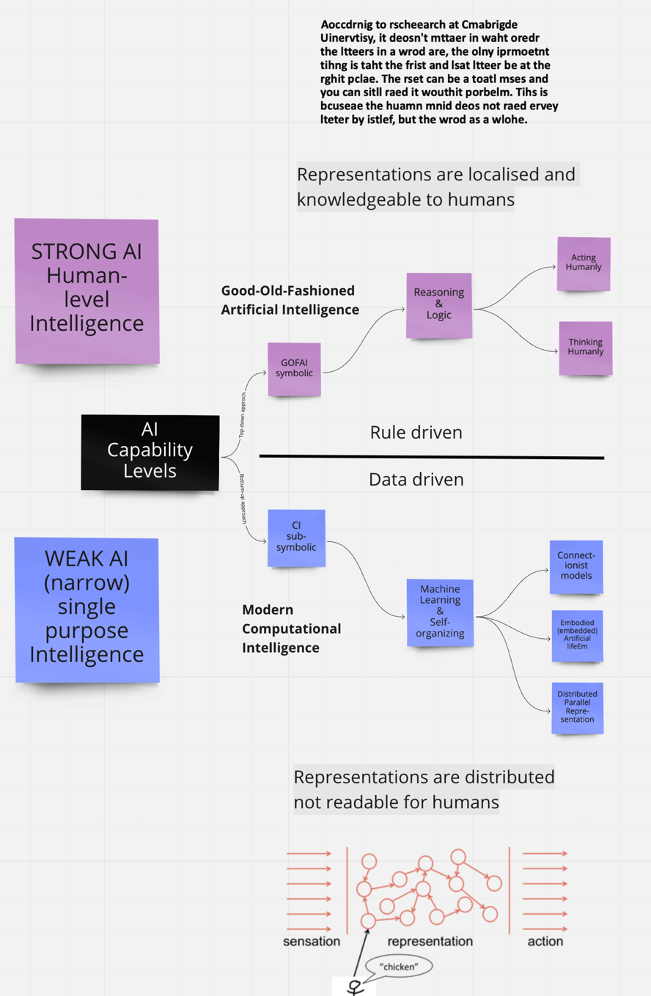



APPENDIX B:

PART II Data (Product) Description, Preparation & Annotation



APPENDIX C:

PART III **AI Model selection, coding, training and testing**

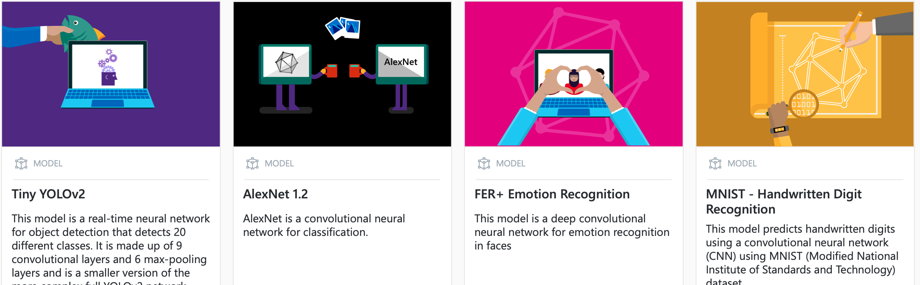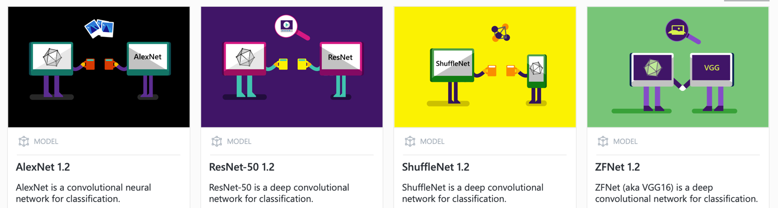

APPENDIX D:

PART IV Critical Reflection & Ethical Considerations

<https://cyber.harvard.edu/story/2019-06/introducing-principled-artificial-intelligence-project>

